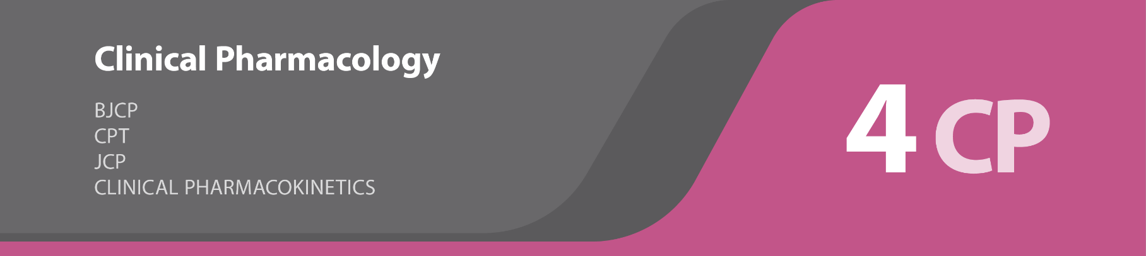

**REPLACE**

British Journal of Clinical Pharmacology

Clinical Pharmacokinetics

Journal of Clinical Pharmacology2

Clinical Pharmacology & Therapeutics

**Founders**

R.S. van Onkelen

J.A. Lafranca

**Editor in Chief**

T. Preijers

**Editors**

C. Stolk-van der Heijden

R. Boosman

L. van der Heijden

W. Al Arashi

R.Q.H. Kloos

J.E. Möhlmann

H. Ince-Askan

**Website** <http://www.4abstracts.com/spin-offs/4ClinicalPharmacology>

**Contact** info@4abstracts.nl

**Facebook** www.facebook.com/4Abstracts

**Manual** The titles in the contents are hyperlinks. Use these hyperlinks and the back button underneath every abstract to navigate more easily through the document. All abstracts have a hyperlink to the website of the journal. Use these hyperlinks to view the article in full-text. Articles can only be accessed in full-text through a personal account or the account of an institution.